ICSS 2018 SPEAKER BIOS

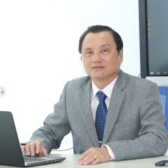
Mr. Pham Huu Loc
Rector of Ly Tu Trong College
Mr. Loc is the current rector of Ly Tu Trong College which is the leading technical college in HCMC. He, also, has worked as a professional lecture in vocational colleges, universities since 1996 and received couples of honour awards from the Ministry of Industry, The Labour Awards, Merit Teacher Award, Certificate of Merit from Prime Minister. Thus, he understands thoroughly how important of training students and of building a smart campus for students to live with, to study in and to be ready for challenges, opportunities in the 21st century labour market especially in the era of the industrial Revolution 4.0 in Vietnam and worldwide.

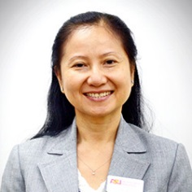
Dr. Nguyen Thi Thanh Phuong
Country Director, Vietnam, Arizona State University
Before joining Arizona State University, Dr. Nguyen was the Country Director for Vietnam Education Foundation (VEF) for ten years. Dr. Phuong oversaw three VEF exchange programs, providing fellowships and grants for over 700 individuals to do graduate studies in the U.S. These programs contributed significantly to developing highly trained human resources for Vietnam in the fields of science, technology, engineering,

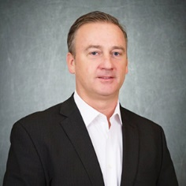
Mr. Jeffrey S. Goss
Associate Vice Provost, Arizona State University
Mr. Jeffrey Goss has served as the Executive Director for the Office of Global Outreach and Extended Education (GOEE) and Assistant Dean in the Ira A. Fulton Schools of Engineering at Arizona State University (ASU) for the past fourteen years. Mr. Goss has more than 20 years of experience in professional and executive education collectively at University of Maryland, George Washington University, University of Michigan, and Arizona State University.

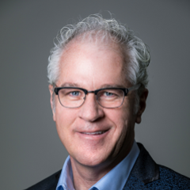
John Rome
Deputy Chief Information Officer, Data Stewardship, Augmented Analytics, and BI
John Rome is the Deputy CIO and a 20+ year employee at Arizona State University (ASU). He is an experienced IT leader, educator, consultant, technologist and innovator with a long history of working in higher education.
John is a pioneer of data warehousing in higher education, building ASU’s data warehouse in the early 1990’s. He is also an instructor in the ASU W.P. Carey School of Business. His areas of expertise include information technology strategy, analytics/business intelligence, data governance, organization development, program management, big data, public cloud development and deployment, and most recently, voice-enabled interfaces.
His special interests include student mentoring, learning science and now voice enabling the world. He holds a Bachelor of Arts degree from Clarke University (Iowa) and a MBA from Arizona State University and is a two-time recipient of ASU’s President’s Award for Innovation.

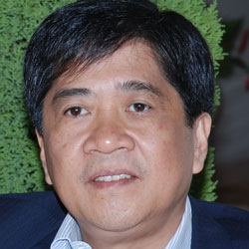
Prof. Dr. Nguyen Loc,
Vice President of Nguyen Tat Thanh University
Before joining Nguyen Tat Thanh University as its Vice President, Prof. Dr. Nguyen Loc was Vice-Director General of the Vietnam Institute of Educational Sciences (VNIES), which serves as the think-tank for the Ministry of Education and Training of Vietnam in the areas of strategies, policies and curriculum development. He used to work for the Secretariat of the Southeast Asian Ministers of Education Organization (SEAMEO) and then became the founder and first Director of the SEAMEO Training Centre in Ho Chi Minh City, Vietnam. Over the last 30 years, Prof. Nguyen Loc has devoted his research on the various issues of education and training.


Jim Garrison, PhD
Biographical Summary
Jim Garrison has served since 2012 as Founder and President of Ubiquity University, an education and technology platform company dedicated to providing innovative and affordable learning globally in partnership with an international network of educational institutions.
Garrison served as Founder and President of Wisdom University from 2005 – 2012, the precursor to Ubiquity, which is now the Wisdom School within Ubiquity. Garrison led the transition when Wisdom University, a California non profit institution, transitioned into Ubiquity University, a for profit company.
Garrison served as President of the State of the World Forum from 1995 - 2005, a non profit he co-founded with President Mikhail Gorbachev, Senator Alan Cranston, and Secretary George Shultz to establish a global network of leaders dedicated to creating a more sustainable global civilization. The Forum convened leaders from around the world and a spectrum of disciplines to its annual and regional conferences and catalyzed the creation of several independent ongoing organizations.


Felicitas Huong Friedrich
CSR Delegate and Education Manger, Schneider Electric Vietnam
Miss Felicitas Huong Friedrich currently serves as the CSR Delegate and Education Manager for Schneider Electric Vietnam.
She lives since 2013 in Vietnam and worked in different Management positions across industries like Textile, IT and Furniture. Thanks to her previous working engagement in Vietnam she has experienced firsthand the great potential as well as the challenges of a fast-growing economy.
As she feels personally strongly connected to Vietnam she wants to contribute to its successful development and therefore joined Schneider Electric, to run its global program “Access to Energy” in Vietnam.

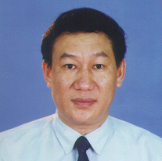
Associate Professor, PhD. Tran Khanh Duc
Senior Teacher of Ha Noi University of Science and Technology

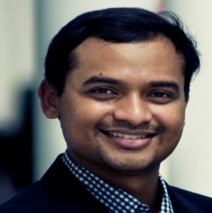
Aru David
Global Director, Private Sector Partnerships & Regional Director – ASSIST
Aru is a currently the Regional Director and Global Head of Private Sector Partnerships in ASSIST, an international NGO. He has been involved in several developmental projects in the Mekong & Africa region (Vietnam, Cambodia, Myanmar, Laos, South Africa, Kenya and Mauritius) for 11 years since 2007. He has successfully implemented and managed 30 PPP projects in the Mekong & Africa region in various focus areas such as Skills & Jobs, Agriculture & Rural Development, Green Economy, Health and Small Business Development. Aru has built a strong network in the developmental sector and has established good relations with several multilateral organizations and donors such as IFC, World Bank, USAID, DEG, GIZ, SEQUA, SIDA, and UN agencies. Aru is also speaker in several conference and forums on sustainable development. Aru has implemented several vocational training projects in the region in partnership with private sector and colleges.


John Vlaar
Chief Vision Officer
John Vlaar is one of the two founders of Electude. John studied both Electrical Engineering and Didactics. He founded Electude with his university friend, Koen Berends. An avid pilot, John was one of the first people to see the potential of automotive e-learning in a gaming-like environment similar to flight simulators. A frequent speaker at major industry events, John is widely seen as leading visionary in automotive education.


Jolanda Tromp
Director of the Center for Visualization and Simulation at Duy Tan University, Da Nang, Vietnam
Dr. Jolanda Gerda Tromp is Director of the Center for Visualization and Simulation at Duy Tan University, Da Nang, Vietnam. She is a Human-Computer Interaction expert specialized in User-Centered design and evaluation for new technologies (VR/AR/AI/IoT), with 20 years’ experience as principal Usability investigator. She has a PhD in Systematic Usability Design and Evaluation for Collaborative Virtual Environments, 2001, University of Nottingham, United Kingdom, a BSc in Psychology (with honors), thesis Presence and Immersion, 1995, University of Amsterdam, Holland, and a minor degree in Arts from the Rietveld Academy, Holland. She worked at the University of Amsterdam, Holland, the University of Nottingham, United Kingdom, the State University of New York, USA, Motorola, and various other startup companies. She is a consultant on the State University of New York Mixed Reality Task Group and the global Simulations Working Group.


Susan D’Aloia
Client Success Advocate for Blackboard, serving the Asia Pacific region
Dr. Susan D’Aloia is the Client Success Advocate for Blackboard, serving the Asia Pacific region. As an interdisciplinary educator and program developer, Susan has worked as a consultant and trainer in the United States, Latin America and Asia. She has worked with public and private schools, non-traditional learning institutions as well as colleges and universities.
Susan has served as a Director, Department Head, an Associate Director and an Advisor and has taught over 1,000 hours of fully online and blended learning instruction. In addition to her doctoral degree, Susan earned a graduate degree in fine arts from Sarah Lawrence College and has a graduate level certificate in education. Her essays and scholarship have been published in journals including the Global City Review, New Renaissance Magazine, Internarrative Identity Revisited from Palgrave Macmillan and in The Future of English in Asia by Routeledge Press. Most recently her work has been published in 21st Century Holistic Learning and ELearn Magazine.


ALEXANDRA (SASHA) STINCHFIELD
Associate Managing Director and Chief of Staff
Ms. Stinchfield is an Associate Managing Director and Chief of Staff for Arizona State University’s Vietnam/SE Asia Programs where she directs project management, planning, and implementation of key strategic and organizational initiatives. Prior to this, Ms. Stinchfield served as a business development specialist for the ASU’s Office of Global Engagement where she managed a portfolio of global projects and proposal development efforts across the disciplines of sustainability, governance, education and health. Ms. Stinchfield has extensive experience cultivating and consulting on major global funded initiates, such as with USAID, World Bank, Inter-American Bank, Foundations, and other donor organizations. Ms. Stinchfield has extensive experience working on international development issues in Africa, Asia and Latin America. She received her BA in Global Studies and a Masters in Sustainability Leadership from Arizona State University.

